Acquiring a dependency grammar: The first three stages
in the acquisition of multiword combinations in Hebrew-speaking children

Anat Ninio
The Hebrew University, Jerusalem
Department of Psychology

Ninio, A. (1998). Acquiring a dependency grammar: The first three stages in the acquisition of multiword combinations in Hebrew-speaking children. In G. Makiello-Jarza, J. Kaiser & M. Smolczynska (Eds.), Language acquisition and developmental psychology. Cracow: Universitas.

Address: Department of Psychology, The Hebrew University, Jerusalem, 91905 Israel.
The reported project was supported by a grant from the Israel Foundations Trustees (1992-94).
INTRODUCTION
This paper presents an attempt to account for the order of acquisition of different three-word constructions in children acquiring Hebrew as their first language. The relative complexity of such constructions is derived from a type of linguistic theory not previously employed as framework for developmental research, namely, dependency grammar. In the last 25 years, the theoretical framework for the study of the development of grammar in children has mainly been the linguistic theory associated with Noam Chomsky, namely, "phrase-structure" theory. Such developmental theories, however, find it rather difficult to account for the order of acquisition of children's initial word-combination, and in particular, for the order in which different type of three-word constructions emerge in child language (e.g., Pinker, 1984:215; for more discussion of these problems see Ninio, 1994). In the following, an attempt will be presented to predict the same phenomenon by the tools of a different grammatical theory, namely, Dependency Grammar.
Dependency grammars occupy a central place in current German and Eastern European syntactic theorizing (eg., Mel'cuk, 1988; Kunze, 1982). In grammars constructed within dependency theory (e.g., Hudson, 1990), syntax is handled in terms of grammatical relations between pairs of individual words, such as the relation of the subject to the predicate or of a modifier to a common noun. Grammatical relations are seen as subtypes of a general, asymmetrical dependency relation: one of the words (the head) exhibits a host of local control phenomena towards another word (the dependent). The overall syntactic structure of a sentence is obtained by the putting together of the different dependency relations existing between its elements.
When we come to the onset of syntax in children, the adoption of Dependency Grammar as a theoretical framework makes it possible to make certain predictions about the order of acquisition of different three-word constructions, and that on the basis of their relative difficulty in terms of their dependency structure, regardless of their characterization in terms of their constituent structure.
The first prediction is that children will find it easier to learn to produce three-word combinations in which pairs of words between which there is a grammatical relation, are also immediate neighbors in the sentence. During sentence generation, if the two members of a dependency couple are to be separated by some intervening material in the sentence, the processing of one dependency relation is interrupted by the processing of another, thus creating an open dependency for the duration. Until the second member of the couple is generated, the speaker has to keep in short-term memory the fact that such a closure is pending. For example, the generation of 'Give him apples' requires that the speaker store the demand for the second dependent of 'give' until after the first dependent ('him') is produced. Similarly, open dependencies also demand extra processing during the interpretation of sentences by listeners.
Below are listed all possible types of well-formed three-term combinations, according to their dependency and linear structure, with some illustrative examples for each pattern. For expository purposes only, a letter-based notation is used to characterize the abstract structure of the different patterns. The words of the pattern are represented by the letters H (for head of a dependency pair) and D (for a dependent). If a head has two dependents, these are marked D₁ and D₂. If a dependent has a dependent of its own, the subordinate dependency couple is put in parenthesis and its members are designated simply as H and D, without otherwise noting that the head of the subordinate combination is also the dependent of its own head, the H outside the parenthesis. Thus, (H D) H is to be read as a construction in which the third word of a sentence is the head of the first word, which in turn is the head of the second. In addition, a redundant notation is also used in the form of directed arrows drawn below these symbols, leading from Heads to Dependents.

#1 H (H D) Take this ball #5 D₁ D₂ H This I dropped
---> ---> <--------
#2 D₁ H D₂ John made this <----
<--- ---> #6 H (D H) Bring big apples
#3 (D H) H Little boys danced --------->
<--- <--- <-----
#4 H D₁ D₂ Put it there #7 (H D) H The boy disappeared
---> --->
-------> <--------

The examples above represent only one of a large number of different 3-term combinations possessing the relevant dependency structure. Thus, the first pattern, i.e.,
-->--> , while representing the structure of a sentence such as 'take this ball', also characterizes utterances such as 'in the house' or 'want see picture'.
The first three patterns are those in which the dependency relations coincide with the neighborhood relations between the words. The other four patterns are those in which one of the dependency couples is not adjacent in the sentence. It is predicted that the all-adjacent (or linear) patterns will be acquired earlier than the non-adjacent (non-linear) ones.

Apart from issues of adjacency, a dependency analysis suggests two other factors that may influence the relative difficulty of a three-word construction. The first is the direction of the dependency relations relative to the dominant direction of most dependency relations in the language. It is well known that most languages of the word have a dominant word-order for the placements of heads and dependents. For instance, Welsh is a language where heads usually precede their dependents, whereas Japanese is a strongly head-last language (Siewierska, 1988). It seem intuitively reasonable that children would find it easier to learn to generate constructions in which the dominant order of the head-dependent relation is conserved. To complicate matters, Hebrew is an (S)VO language (Berman, 1980), namely, a language in which most dependency relations with the exception of the subject-predicate relation put the head of the combination to the left of the dependent. Moreover, due to the existence of a rich agreement-marking system, it is possible to construct grammatical sentences without expressing the subject by a lexical noun phrase. Thus modern Hebrew appears to possess two different dominant linearization patterns: a head-first pattern and a mixed SVO-type in which heads accept dependents both to their left and to their right.
The developmental prediction that follows from this pattern is that children would find it identically easy to acquire pure head-first patterns of three-word combinations such as H (HD) as well as the head-in-the middle types D₁ H D₂. Both are expected however to be easier to acquire than head-last patterns such as D₁ D₂ H.
The second possible factor of difficulty is the number of dependents per head. In chained three-word combinations such as H (H D) each head accepts a single dependent; however, in order to produce a three-word string, it is necessary to chain the first dependency with the second. By contrast, in branching coordinated three-word combinations like D₁ D₂ H each head gets two different dependents that need to be coordinated among themselves. It is possible that the coordination of two dependents for a single head is more complex than the chaining of several single-dependent relations, as the former involves some extra lexical learning of the complex argument structure of multiple-argument predicates. However, it is difficult to weight this factor against the increased complexity of a three-level hierarchical structure created by chained dependencies.
METHOD
Sample: In a previous phase of the study, two samples of Hebrew-speaking mother-infant dyads were observed and videotaped for 30 minutes at a time in their homes, while engaged in activities of their choosing. The samples consisted of 8 children each who were followed up 6 times during a year, being observed once in every two months. The first group were observed between 18 months and 28 months, the second, between 22 months and 32 months. The samples were balanced for sex and parents' level of education.
All three-term utterances produced by the 16 children were analyzed for their dependency structure. There were 2,510 were analyzable three-word utterances in the corpora.
RESULTS
The children of the sample produced 6 different types of three-word sentences. Figure 1a presents the frequency of each type by age at observation.
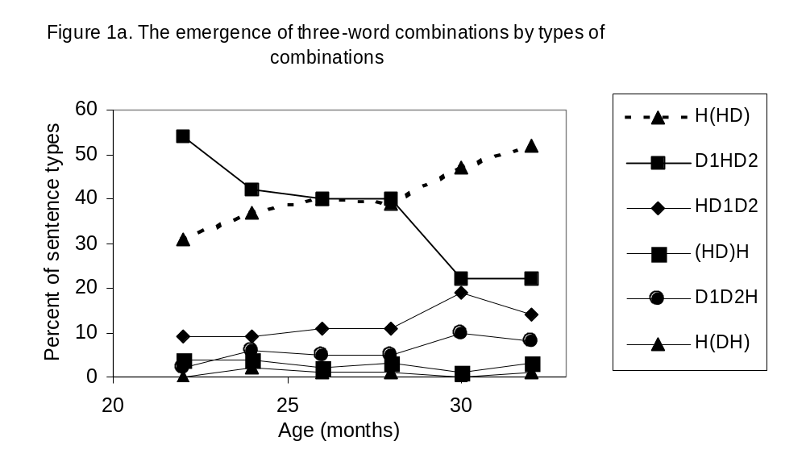
It is evident that within the age-range studied here, the majority of children's three-word combinations fall into two patterns: about 37% overall belong to the heads-first chained linear type H(HD), while 41% belong to the head-in-the-middle, branching type D₁HD₂. Other 4 possible 3-term patterns occurred with low frequency in the corpus, and one was not produced at all.
We shall return to a discussion of the development of the individual three-word patterns at the end of this paper. First, the effect of three possible factors on these results will be isolated and examined in detail.
Figure 1b presents the distribution of three types of sentences by age: sentences in which all dependents are immediately adjacent to their head(s); sentences in which a dependent is separated in the string from its head by a co-dependent; and sentences in which a dependent is separated from its head by its own dependent (or subordinate).
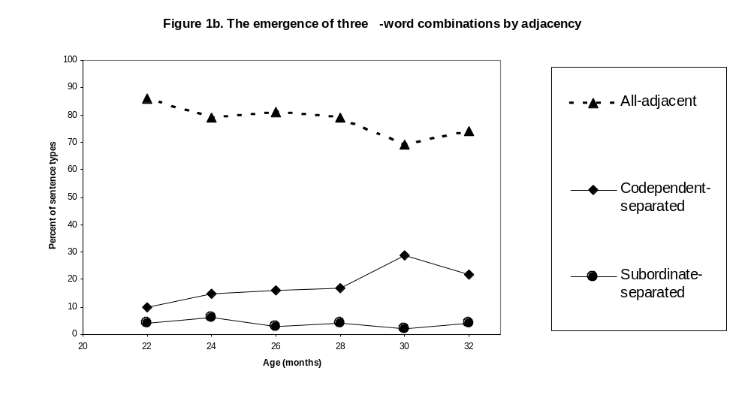 The results show that the all-adjacent or linear pattern constitutes about 80% of all three-word sentences at this age group; moreover, its proportion continues to be very high throughout the 22-32 months period, with a very slight tendency to decrease. The next frequent is the codependent-separated pattern, constituting about 17.5% of all sentences; this pattern gains in frequency with increased age. The third type -- subordinate-separated sentences -- accounts only for less than 5% of the overall production, and its frequency does not show a tendency to increase with age in the investigated age range.
Regarding order of emergence of the three types of sentences, examination of the data of the individual children and a non-parametric sign-test performed on the data revealed that the linear pattern begins to be produced at an earlier age than either the co-dependent or the subordinate-separated patterns (p<0.001). Similarly, the co-dependent separated patterns starts to be produced highly significantly before the subordinate-separated patterns (p<0.001).
To conclude, children begin the production of three-word sentences by producing word-combinations in which both dependents are immediately adjacent to their head. Such patterns account for the great majority of all sentences until 32 -- the end of the period investigated. Only towards the end of the period -- 30-32 months -- is there a decrease in the relative frequency of all-adjacent sentences. Co-dependent separated sentences are acquired later, and their relative frequency increases in the investigated age range. Subordinate-separated sentences start to be used yet later and occur only sporadically throughout this period.
The next analysis concerned the possible effect of the linear positioning of the head(s) in three-word sentences on the order of their acquisition. Figure 1c presents the distribution of three categories of sentences by age: sentences in which one or two heads are to the left of their dependent(s), i.e., Head-first; sentences in which the head(s) are to the right of the dependent(s), and mixed patterns in which both directions of linearization appear.
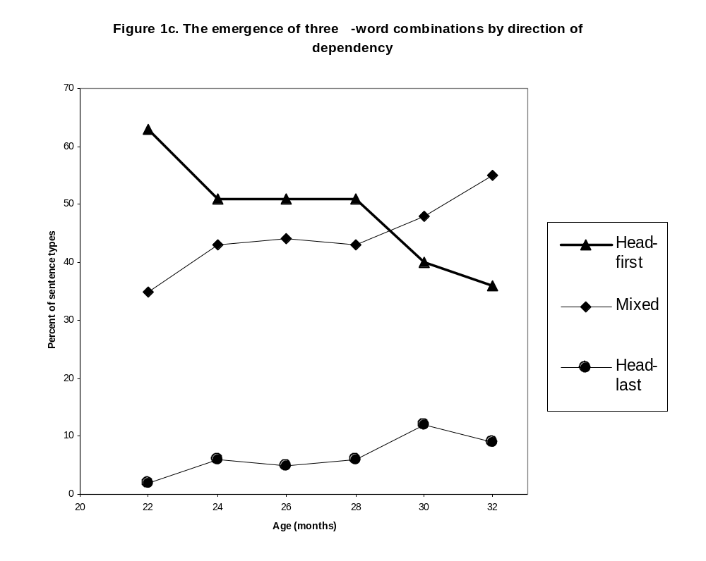
Overall, about 49% of all sentences produced by the children were Head-first, and about 45% the mixed type. Only about 6% were Head-last. Moreover, the head-first type decreases in relative frequency during development, whereas the other two types increase in relative frequency.
Examination of the order of emergence of these sentence types in individual children revealed that the Head-first and the mixed-order types emerge at the same ages; there was no significant difference by sign test (nor was there a nonsignificant trend of any sort) between their ages of emergence. However, at the onset of the period the head-first pattern generated about twice as many sentence tokens of this type than the mixed type, a pattern of results that changed direction in the middle of the period.
The Head-last pattern was first produced at a significantly later age than the former two (p<0.001), and even by the end of the period it did not account for more than about 10% of all three-word sentences. This type of sentence was produced only sporadically and in small numbers throughout the period.
To summarize, there was no significant difference between the age of emergence of Head-first and mixed-direction sentences, but the former was more prolific at first. Mixed-direction sentences "caught on" and started to generate many sentence tokens later on; by 30 months their frequency was greater than that of Head-first sentences. Head-last sentences were acquired later than the other two, and were marginal in frequency throughout the period.
The last analysis concerned the possible effect of chaining vs. branching as the strategy of producing three-word utterances, on the pattern of their acquisition. Figure 1d presents the distribution of two categories of three-word sentences by age: sentences in which there are two heads, each getting a single dependent, when the dependent of one pair is the head of the other pair (chaining); and sentences in which one head had two dependents (branching).
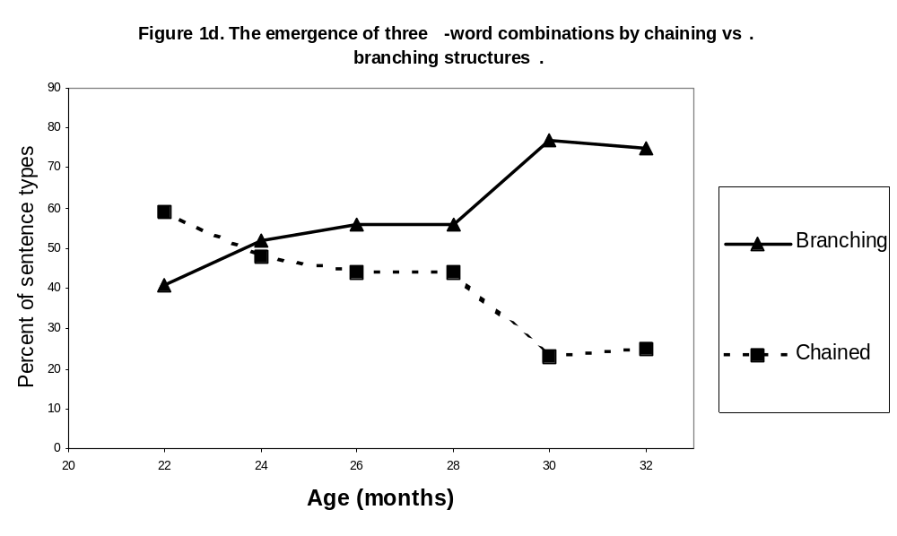
Overall, the relative frequency of the branching type is higher (59%) than of the chained type (41%). However, the chained type is more frequent at the start of the period; it undergoes a decrease in relative frequency throughout the period, whereas the branching pattern increases in frequency. The two are about equal in frequency at 24 months, but from then on branching is the more prolific pattern.
Examination of the individual acquisition data revealed that there was no difference between the age of emergence of the two type of patterns, nor was there a trend for one of them to be acquired earlier in the whole sample. The majority of children started to produce both at the same age; a minority of the children showed a delay in one pattern relative to the other.
In summary, branching and chained constructions are acquired at about the same time, but chaining is more productive at first, while branching start to generate more than half of all three-word utterances past 24 months.
Putting these separate trends together, and returning to the individual three-word patterns presented in Figure 1a, it appears that the development of three-word sentences undergoes the following stages:
First stage: children acquire two ways of combining three words into a syntactically connected sentence. Both involve an all-adjacent placement of heads and dependents, without any separation between dependency-pairs. At first, the more productive of the two is a Head-first, chaining pattern H(HD).
Second stage: The other of the initially acquired patterns of combination accelerates in productivity, and surpasses the initially dominant pattern. This is an all-adjacent, Mixed-direction, branching pattern D₁HD₂.
Third stage: children acquire and increasing use a third pattern of combination. It is a branching pattern (one head with two dependents) which is no longer all-adjacent, but rather, one dependent is separated from the head by the other dependent. The head is on the left, namely, this is a head-first pattern -- HD₁D₂.
Not acquired at this period in any way but sporadically the all-adjacent head-last pattern (DH)H, the branching, co-dependent separated pattern with the head placed last, namely, D₁D₂H, and two subordinate-separated patterns H(DH) and (HD)H.
The overall pattern of results suggests that the most important determinant of structural complexity is the degree of separation between heads and dependents; patterns in which there is no separation whatsoever, vastly outnumber in frequency and precede in acquisition the separated kind in this initial stage of producing three-word word-combinations. When there is no complete adjacency, codependent-separation is less complex than subordinate-separation; the latter type is not yet mastered in a consistent manner by 32 months.
Chaining and branching dependencies is a priori equal in complexity, but the differences in productivity show that chaining two dependencies is the most basic structural operation, mastered the earliest.
The placement of heads does influence ease of acquisition, although in a mixed-linearization language such as Hebrew both patterns are acquired at the same time. Still, the frequency data suggests that Head-first is the most basic pattern, with mixed-order following. Head-last is not really mastered at this initial stage of acquisition except sporadically.
DISCUSSION
The obtained pattern of results demonstrates that a dependency-syntax oriented acquisition model has considerable success in predicting what kind of sentences will a child first acquire on starting to combine more than two words in a single sentence. In making these predictions, the dependency-oriented developmental theory does not assume that a child has recourse to innate syntactic knowledge which is suddenly made available to the child. On the contrary, the acquisition of syntactic knowledge is seen as a continuous and gradual process, firmly built on the foundations of two-word speech and even of learning carried out in the single-word period.
Overall, the developmental evidence presented in this paper demonstrates that an acquisition theory adopting dependency grammar as its theoretical framework is successful in accounting for a series of developmental phenomena connected with the acquisition of syntactic knowledge. This finding, together with the limited success of phrase-structure oriented acquisition theories to account for the early stages of multiword speech, raises the possibility that a dependency grammar may be a better approximation to implicit grammatical knowledge in people than a phrase-structure type grammar. Consequently, the adoption of dependency theory as a linguistic framework of child language research may bring about a better understanding of the child's task in acquiring syntactic knowledge than we currently possess, exchanging such terms as innate higher-order syntactic constituents with units of knowledge more firmly anchored in observable developmental patterns.
REFERENCES
Berman, R. (1980). The case of an (S)VO language. Language, 56, 759-776.
Hudson, R. (1990). English Word Grammar (Oxford: Basil Blackwell).
Kunze, J. (1982). Automatische Analyse des Deutschen. Berlin: Akademie-verlag.
Mel'cuk, I.A. (1988). Dependency Syntax: Theory and Practice (Albany: State University of New York Press).
Ninio, A. (1994). Predicting the order of acquisition of three-word constructions by the complexity of their dependency structure. First Language, 14, 119-152.
Pinker, S. (1984). Language Learnability and Language Development (Cambridge, Mass.: Harvard University Press).
Siewierska, A. (1988). Word Order Rules (London: Croom Helm).

